You are Invited to our Reception Honoring

Rebekah Assembly of Ontario President Elect:
Sister Bonnie Desjardins
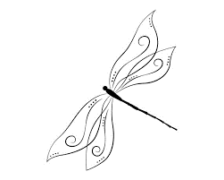
Glen Rebekah Lodge No209

Saturday, June 15 2024

Doors open at 4:30pm Dinner Served 5:30pm

Penetang Royal Canadian Legion #68
2 Poyntz St, Penetang (behind Foodland)

Dinner includes Roast Beef, Mashed Potatoes,
Seasonal Vegetables & Dessert

Cash Bar

Tickets $45
Can be purchased from Sister Joan Snedden:
705-322-9637
Paid tickets will be held at door
Cheques made payable to: Joan Snedden
Mail cheques to:
Joan Snedden, 56 Archer Cres, Elmvale, ON, L0L 1P0
Tickets available until May 17 2024

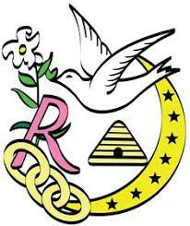
Sunday Breakfast hosted by
Glen Rebekah Lodge via Sister June Ritchie
Served 10 – 11 am
16948 County Road 27, Elmvale, ON
705-322-2413

Hotel Group Rates:
Quality Inn | Super 8
924 King St, Midland  705-526-9307 ex: 0  Rate: $ 130*, 1 King or 2 Queen  Rebekah Preferred Hotel  Restaurant on location  1 Accessible room available upon request | 1144 Hugel Ave, Midland  705-526-8288  Rate: $159*, 1 Queen or 2 Queens  This hotel is closer to banquet location Complimentary hot breakfast included  1 Accessible room available upon request

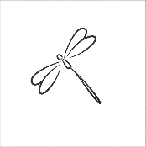
*Room rates are only available directly though hotel
Rooms are held under “Rebakah Assembly of Ontario”
Rates and rooms held only until May 14 2024

